
Lord Strathcona’s Horse (Royal Canadians)
Ceremonial Mounted Troop
Cavalry Ride

@strathconamountedtroop
Booking Request Forms

Please fill out the required forms in order to book the Strathcona Mounted Troop for your event. The completed package must be received no later than 60 days prior to your scheduled event.
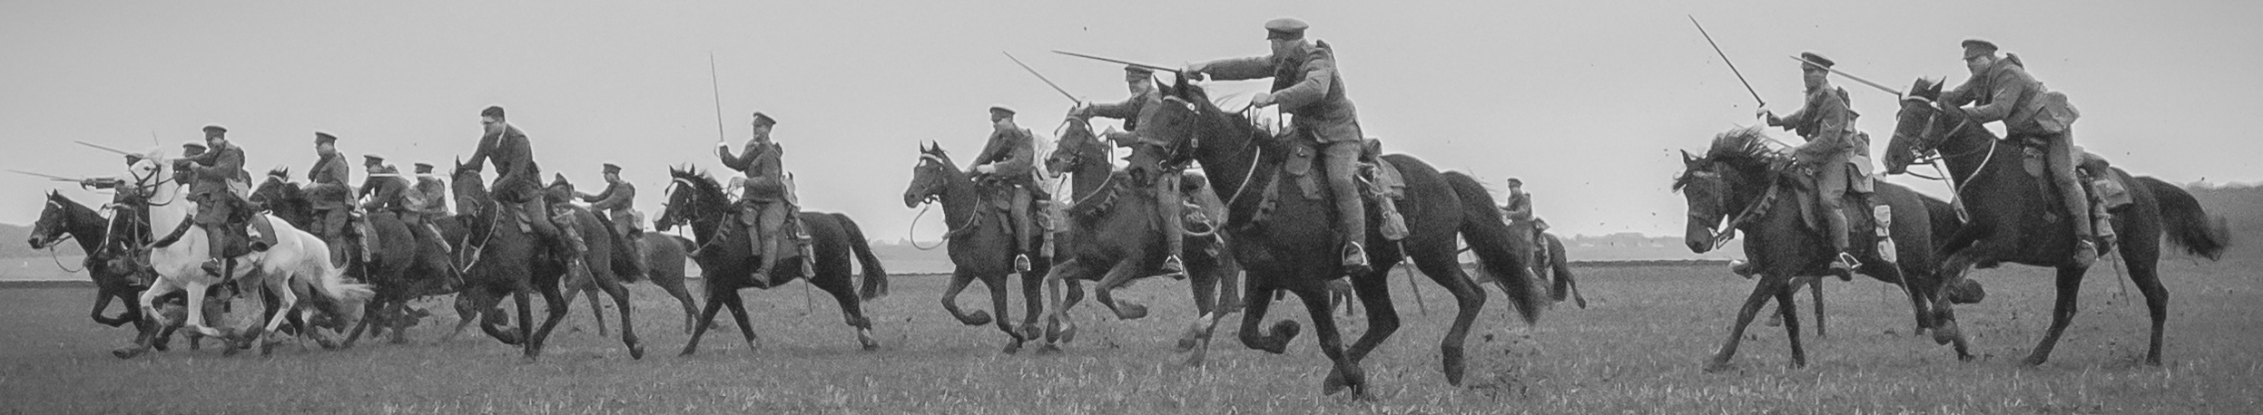

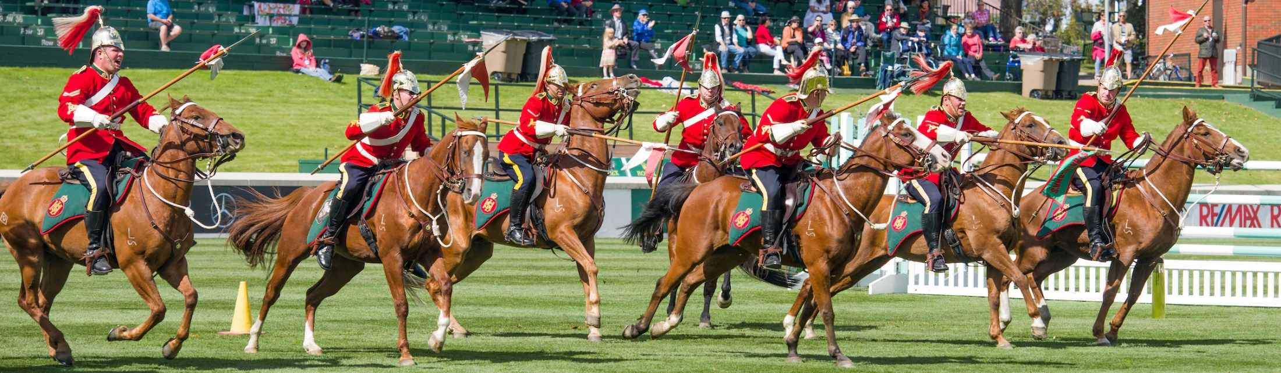

Application form includes 3 Forms:

Form A – Event Confirmation (outlines the key event information for your venue)
Form B – Basic Ride Requirements (lists the essential requirements necessary for hosting our Musical Ride)
Form C – Overnight Requirements (contains the requirements for hosting our Musical Ride if the Troop must stay one or more nights in your area (which will be determined by performance demands and travel distances))

Honorariums: $3000 per ride depending on travel distance to your venue. If your event books the Strathcona Mounted Troop for more than 4 rides, negotiations on price can take place.

Please Note: If the event is cancelled by either party due to inclement weather the event organisation will be liable for 50% of the honourarium. If the event is cancelled due to inclement weather, your event will receive priority in the next booking season. If the event is cancelled for any other reasons within 30 days of the event, the event organization will be liable for 50% of the honourarium.

Please return your completed application form(s) to:

Strathcona Mounted Troop
Lord Strathcona’s Horse (Royal Canadians)
P.O. Box 10500, Station Forces
Edmonton, AB T5J 4J5
Bus: (780) 271-4397
Fax: (780) 973-1491
E-Mail: smt@strathconas.ca
Lord Strathcona’s Horse (Royal Canadians)
Ceremonial Mounted Troop
Cavalry Ride

Application Form A
@strathconamountedtroop
Event Confirmation

Please complete this application form and return to:

Strathcona Mounted Troop
Lord Strathcona Horse (Royal Canadians)
P.O. Box 10500, Station Forces
Edmonton, AB T5J 4J5
Bus: (780) 271-4397
Fax: (780) 973-1491
E-Mail: smt@strathconas.ca

The Strathcona Mounted Troop will contact you within 5 business days to acknowledge the receipt of this application form and discuss with you any issues regarding the information provided in your application. Once this year’s ride season schedule is finalized, we will contact you again to confirm your booking.

1. Event Information
Please provide a brief description of your event:

2. Contact Information
Position and Contact Name: |  |  | Cell #:
Phone #: |  |  | Fax #:

3. Musical Ride Information
Location: |  | Date: |  | Time:
Location: |  | Date: |  | Time:

4. Parade Information (if applicable)
Name of on-site Coordinator:
Parade Date, Time, and Location:
Judging Time and Location:
Marshall Time and Location:

5. Special Events (event ceremonies etc.) (if applicable)
Event Description:
Event Date, Time, and Location:
Name of on-site Coordinator:

6. Dress Requested (Circle) World War I Ceremonial (Scarlet)

7. Confirmation:
I have read the Booking Package, and have filled out the information to the best of my ability. I acknowledge and accept the $3000 per ride honourarium as well as the additional costs outlined in Form C. In addition I confirm that inclement weather may force the cancellation of the Musical Ride. If the event is cancelled by either party, the event organisation will be liable for 50% of the honourarium. If the event is cancelled for any other reasons within 30 days of the event, the event organization will be liable for 50% of the honourarium.
Signature:
Date:
Lord Strathcona’s Horse (Royal Canadians)
Ceremonial Mounted Troop
Cavalry Ride
@strathconamountedtroop
Application Form B
Basic Ride Requirements

The following is required from your venue in order to accommodate our Musical Ride: (Please contact us if any of these requirements cannot be fulfilled.)

Musical Ride Performance Area Requirements:

Basic Requirements Checklist
Directions and Map |  |  |  | Checkmark
Directions to the Musical Ride performance area and map or grounds |  |  |  | □
Parade Route and Marshalling Area (if applicable) |  |  |  | □
Musical Ride Performance Area
Ride performance area: 150 x 250 feet |  |  |  | □
Ensure the performance area is free of rocks and holes |  |  |  | □
Ensure the performance area is both watered and groomed prior to the Musical Ride (if the performance area is dirt) |  |  |  | □
Power Supply (110v) and extension cords |  |  |  | □
Vehicle and Trailer Requirements
Ensure the area is suitable for unloading and loading a 55 ft horse trailer, 53 ft tack trailer, and 4 passenger vans near the performance area |  |  |  | □
Ensure there is reserved parking for 4 passenger vans near the performance area |  |  |  | □
Horse Requirements
Ensure there is a suitable holding area for 20 horses (horses can be tied off to our trailer if the ground is fitting) |  |  |  | □
Horse feed: up to 12 high-quality square bales of hay per day |  |  |  | □
Ensure there is a water supply close to the performance/horse holding area. |  |  |  | □
Ensure to have a local Vet and Farrier on stand-by (for emergencies)
Local Vet Name: |  | Phone #: |  | □
Local Farrier Name: |  | Phone #: |  | □
Personnel Requirements |  |  |  | □
Provide up to 3 quality meals for up to 26 personnel or monetary equivalent (dependant on distance travelled), (individual cost for meals are as follows: Breakfast $15, Lunch $15 and Supper $35) |  |  |  | □
Provide complimentary show tickets for rider’s family members (if applicable) |  |  |  | □

Confirmation:
I have read and accept the Strathcona Mounted Troop Basic Requirements Checklist and confirm we can provide each requirement.

Signature:
Date:

Lord Strathcona’s Horse (Royal Canadians)
Ceremonial Mounted Troop

Application Form C
Overnight Stay Requirements (24 hours or more)

The following is required from your venue in order to accommodate our Musical Ride: (Please contact us if any of these requirements cannot be fulfilled.)

Musical Ride Performance Area Requirements:

1. Stabling Requirements:
a. Stable Name and Location: __________________________________________________________
b. Stable Contact Name and Phone #: ___________________________________________________
c. Stabling for 20 horses: Box stalls / Paddock (circle one)
If circled Box Stalls:
- Bedding in Stalls: ½ Bale Straw / Wood Shavings / Dirt (circle one)
- Fresh bedding available for daily muck-outs.
- Waste disposal area close by for daily muck-outs.
If circled Paddock:
- Paddock Type: Grass / Dirt (circle one)
- Please ensure paddock is free of large rocks and holes; no barb-wire fencing.
d. Rider warm-up area (if available).

2. Accommodation Requirements:
a. Hotel Rooms (max 2 people per room) or suitable accommodation onsite for 26 people.
b. Name of Hotel or other accommodations: ________________________________________________
c. Address: _____________________________________________________________________
d. Booking Coordinator Name: ______________________________________________________
e. Booking Coordinator Phone #: ____________________________________________________
f. Parking for 4 passenger vans.

3. Please provide a detailed overhead map or diagram of:
a. Directions to the Horse Stables (or paddock) and Hotel.

4. Horse Requirements:
a. Horse Feed: 12 high-quality square bales of hay per day.

5. Vehicle and Trailer Requirements:
a. Please ensure there is a suitable area for unloading and loading our 55 foot horse trailer, 53 foot tack trailer and 4 passenger vans near the stabling and performance area.
b. Reserved parking for 4 passenger vans near the stabling and performance area.

6. Personnel Requirements:
a. Please provide 3 quality meals per day for up to 26 personnel (or food allowance of $65 per person per day).
b. Please provide complimentary show tickets for riders’ family members (if applicable).

Confirmation:
I have read and accept the Strathcona Mounted Troop Overnight Stay Requirements and confirm we can provide each requirement.

Signature:
Date:

